well, yeah However if your car no longer has emissions equipment then it's trivial to rig up something that not only works, but works better than factory.
find a big vacuum nipple on the intake manifold that sees vacuum all the time. on '81-85 manifolds there is a perfect one that is above the #2 rotor. run a hose from that to the threaded end (it's a tight squeeze but it will go over) of a Mitsubishi PCV valve (for a random vehicle, get one for, say, a '92 Dodge Caravan with the 3.0l V6), then run a hose from the other end of the PCV valve to the nipple on the OIL FILLER TUBE. Then, run a hose from the nipple on the CENTER HOUSING to the filtered side of the air cleaner assembly. It is important that it's the oil filler tube that sees the vacuum from the PCV valve because it's the one that doesn't have oil splashing up against it.
That's how i did it to my '83 12A. I'm sure that a GSL-SE would be similar, the only difference being, of course, finding an approprate nipple to hook to the PCV valve, and then routing the breather side to the throttle body duct.

So, to summarize,
An Oil Breather on the filler neck would be the best and simplest solution?
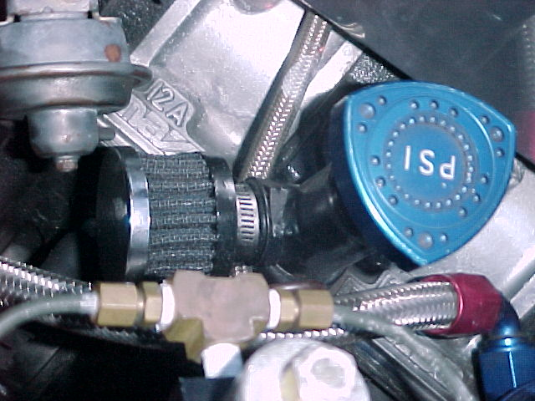

you can't run just one line. you have to run BOTH lines so there is airflow through the inside of the engine.
Run a line from the clean-air side of the air cleaner, directly to the nipple on the center housing - NOT the one on the filler neck!
Now run a line from the intake manifold to the filler neck, and splice a PCV valve in this line. I used a common one that many Mitsubishi engines use (try, say, '92 Caravan with the 3.0l engine, as a specific example if you need one) because they are easy to tell the engine end from the other and both sides are fairly easy to stuff into a vacuum hose. The threaded end is the one that goes towards the intake manifold.
Now what happens is, fresh air is flowing through the engine, from the air cleaner to the center housing (where the main oil drainback, and most of the internal cavity, are) through down to the bottom of the engine up the filler neck through the PCV hose and into the intake. Without the constant fresh airflow the condensation WILL build up.
Oh, and if you get the two lines mixed up at the center housing, the engine vacuum will suck on all the direct oily mist from the inside of the center housing, which can get spectacular.

The condensation is a natural by-product of gasoline combustion. Like Pele says, it gets into the oil from exhaust blow-by.
The purge valve goes from the vacuum source on the carb to the crank. But if you don't have another opening for fresh air entry, there will be no flow to carry away the water vapor and other nasties. So that's why the nipple on the filler spout. That gets hooked to the charcoal canister.
The canister is just a box o' rocks that provides alot of surface area for fuel vapor from the tank to collect onto when the fuel expands from heat. There's a valve inside, and a nipple at the bottom (84-85) for the tank to contract (prevent vapor lock, scince the rest of the system is trying to suck out the vapors). This bypass valve has no effect on allowing more air into the purge system.
The oil spout filler goes to the box 'o rocks, and then to the top of the carb. This is your fresh air source.
So the purge valve is keeping the crank case free of water vapor, and they 'kill two birds with one stone' by having it suck out the canister, too.
It is'nt set up so that the water vapor from the crank goes through the canister because that would just make a slurry of crap in there.
They get all they need, and all this combined with a valve that closes off the whole system (float bowl solenoid) when the car's off.
Poof...No emissions leaks. It all get's burned.
And speaking of leaks, well your whole carburetor is one controlled leak! So don't be concerned with the purge valve "leak" in your carb system. It's a constant, not a variable, and the carb simply is tuned to compensate....That is, if there's anything to compensate for - Afterall, there's an awful lot of fuel vapor from your gas tank in that "leak".
"Of course, that's just my opinion- I could be wrong."

Alright I think I fixed the problem...
Peejay you were right, I had it hooked up to the carb vent, no vacuum at all.
So all I did was hook up the oil filler neck to the aforementioned intake manifold nipple underneath the shutter valve arm (over the rear rotor). That yielded lots of vacuum. I left the carb vent open.
So here's how my system works now:
The fuel tank vent goes to the charcoal box o' stones, which in turn goes to the center housing nipple. The oil filler neck goes to the intake manifold. That's all, no air cleaner connections.
It's obvious that things are different now, if I remove my oil cap the engine dies out. I had to readjust my idle speed and mixture quite a bit too, as it was idling way too high and rich.
So what do you guys think? Have I screwed up by not incorporating a fresh air source? Is it bad that my manifold is sucking away at the crankcase and canister and all that? Maybe I should run the air cleaner to the center plate and forget about the charcoal box?
So many questions...

Silver, I PM'd you on this subject. I suggest you unplug that vaccum line from your oil filler neck before something really bad happens.

Drill a small hole in your oil filler cap, and hook it up the way you had it the first time. That, or put a small K&N breather filter on the oil filler tube.

